Scottish Schools' Orienteering Festival

Dechmont Law
and
Deans Community High School

Date/Time: Friday 5 June 2015 (c.1000 – 1400 hours).

Directions: Leave the M8 at J3 and head south on the dual carriageway for approx. 0.5 mile to the first multi junction (“Houston”). Turn off at this junction/slip road and then turn right to go underneath the dual carriageway and follow signs straight on/west to Deans. After approx. 1 mile you will reach a large roundabout, where you turn right and head up past the railway station. Turn right at the second junction (approx. 0.4 miles from the roundabout) – you should be able to see the modern school building:–
Deans Community High School, Eastwood Park, Livingston, EH54 8PS.
OS grid ref. NT 033694

Parking: The event arena/assembly and some minibus and coach parking are alongside/behind the school. Some car parking is across the road. There is also a car and coach overflow parking area in use approx. 0.5 mile away, so it would be wise to be prepared for an efficient drop off or walk back following (red and white) tapes. There will be a marshal in a high-vis vest at the junction outside the school to direct drivers accordingly. There might not be a marshal at the overflow car park, so please bring copies of the parking and arena maps for directions.

Leadership/Responsibility: Teachers, parents and other adults that bring a group/children are expected to manage and take responsibility for their group/children. Please note that it is a normal school day at Deans, with classes in session between 0900 and 1220 hours, so make sure your children are aware of this and the need to keep the noise down and not stray into any parts of the school other than the allocated toilets/changing rooms and registration/download.

Registration: On arrival an adult team leader should go to registration to collect the SI dibbers (timing devices) for those that do not have their own, a list of start times and any other information for their children. Take care to give the correct dibber to each child and make sure any unused dibbers are returned. Please warn the children that lost dibbers will cost the school £30. Can those orienteers who have their own SI dibber, please bring it to the event and use it. Registration is under the veranda adjacent to the main door to the school.

Toilets: Boys and girls toilets/changing rooms can be accessed through a back door to the school, on route to the start.

Start: Competitors start at minute intervals on specific allocated start times. The start is reached by walking all the way round the back of the school (beyond the toilets, round the corner of the building and through a back gate). It will take 5–10 minutes from the assembly area.
Finish & SI Timer Download: The finish is adjacent to the assembly area. However, every competitor must go to the download immediately after they finish, even if they retire. Download is in the same location as registration (under the veranda adjacent to the main door to the school).

Courses: Where schools have entered pairs on courses the pair should only pick up one map at the start line and should stay together throughout their run. Please note that any mixed pairs must compete on the Boys course for the relevant school year age class. Please note some schools have asked for entries for their pupils using the colour coded system in mainstream orienteering. This system does not apply here. Pupils will run in the appropriate year group course which has been planned appropriately.

Hygiene: Please ensure your group/children wash their hands after running and before eating.

First Aid: A First Aid Company will be in attendance, located in the car park closest to the assembly or in the assembly itself.

Map: The map was updated in Spring 2014 (scale 1:5,000 and 5m contours). A black X on the map is a bench. The courses will be over printed on waterproof paper. There will be no legend on the maps. If required copies of the legend are available at registration.

Controls and Disqualifications: Please make your children aware that there will be a lot of controls in the area, so they might come across controls that are not on their course. They are meant to visit their own controls in numeric order. However, children who cannot find controls or punch the wrong controls will not be disqualified, but will have a ten minute penalty added for each of these controls. Children who deliberately miss a control may still be disqualified.

Terrain: Dechmont Law is a well-used community park and woodland area in central Livingston, popular with dog walkers. It is adjacent to Deans Community High School, who are our hosts for the day. The orienteering area is bounded on its south and west sides by houses/suburban streets, on the east side by a golf course, and to the north by the M8 motorway. Both the motorway, itself bounded by a high fence, and the golf course are marked as out of bounds for all competitors.

The parkland area is mostly rough open grassland, with rides of mown grass cut into them. These show as bright yellow on a pale yellow background. Many of the courses will use these rides, as well as other paths. In the map extract below:
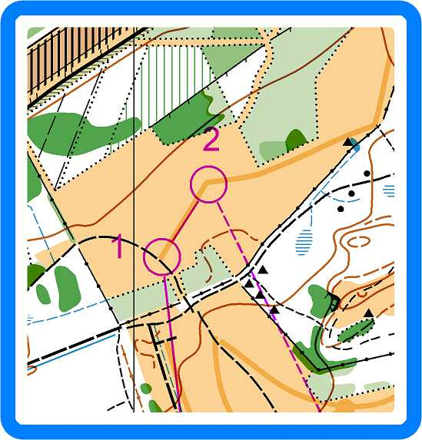
control number one is a “track – ride junction”;
control number two is a “ride bend”.

The longer courses cross a cul-de-sac residential road. Please advise your children to obey the marshal’s instructions. Please also instruct your children that the motorway along the northern edge of the map is out of bounds (courses have been planned to avoid it).

Hazards: A risk assessment has been carried out and will be on display at registration or the assembly. Please read the risk assessment and advise your group/children of the risks and how to stay safe. Please also advise them as follow:

It is a normal school day at Deans, so there will be other people using the school, including pupils attending classes. Please be courteous, keep the noise down, do not stray into other parts of the school and look after your own belongings.

Watch out for and give way to traffic in the car parks, gate ways and cul-de-sac (we do not have exclusive use of the car parks or roads). The motorway, along the northern boundary of the area, is out of bounds (courses have been planned to avoid it).

Take care around the ponds, steep slopes, rough terrain and slippery ground, including paths where mud and roots exist. Forest workers have left some logs and brash, so please keep an eye out for these and any other hazards and avoid them.

There will also be other people in the competition area perhaps cycling, walking dogs, etc., so please take extra care, give way and be courteous. Please also take the weather conditions/forecast into account and ensure your group/children dress accordingly.

Please note that participants take part at their own risk and are responsible for their own safety during the event.

Safety: Please wear appropriate clothing, especially full leg cover (no shorts) and footwear with a good grip. It is recommended that competitors carry a whistle (for use in an emergency only - the call is 6 blasts, gap, repeat...). If the weather is bad it might be made compulsory to carry a whistle and cagoule/coat

Privacy: When entering our events you are accepting that your name may appear in results on the web site or reports. We will not use it for any marketing purposes.

Trophies and Prize Giving: There are team trophies for each course worked out from the total time of the best three from the school. Overall Schools Trophies, Primary and Secondary, go to the school with the most runners within twice the winners time. Prize giving is expected to be about 1330 hours or soon after, either in the school or the assembly area. Current Trophy holders should return the Trophies to registration on arrival.

Acknowledgements: We would like to thank Deans Community High School, West Lothian Council and the Woodland Trust, who have allowed us to use their land and buildings. SSOA would particularly like to thank Interlopers Orienteering Club and all the individual volunteers who have given up their time to help organise this event. We would also like to thank anyone we have inadvertently missed from the acknowledgements.

